Backup-ToSystem: abusing the permissions of "Backup operators" and the VDS service
Created by contributions on June 11, 2020
Good, how are you bad heads? My name is Luis Vacas or CyberVaca as some know me… and in this post we will talk about the permissions granted to the “Backup Operators” group

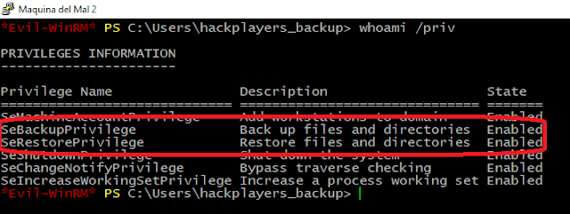
SeBackupPrivilege
➔ "Allows the user to bypass file and directory permissions to back up the system. It makes sense that this privilege exists so that system backups can be performed. The privilege is selected only when the application tries to access it via NTFS backup application interface. Otherwise, normal file and directory permissions apply"
➔ With this privilege you can easily back up the Windows registry and use third-party tools to extract hashes NTLM locales. How for example secretsdump.py from impacket .
So far so good, but wait a minute, if this privilege allows you to read all system files, maybe we can take advantage of it. So we'll try to change the ACLs on some path that we shouldn't be able to write to, but wait, what the heck is an ACL?
ACL
➔ An access control list (ACL), with respect to a system, is a list of permissions attached to an object. An ACL specifies which users or system processes have access to objects, as well as which operations are allowed on which objects. Each entry in an ACL specifies a user or group and an operation. For example, if a file object had an ACL containing (Administrator: read, write; Bob: read), this would give Administrator permission to read and write the file and Bob only to read it.
Well, since we are clear about the concepts, we are going to see if we can abuse it.
First we are going to remove the ACLs from a path that we should not be able to write to, such as “c:\windows\system32\drivers\etc\”.
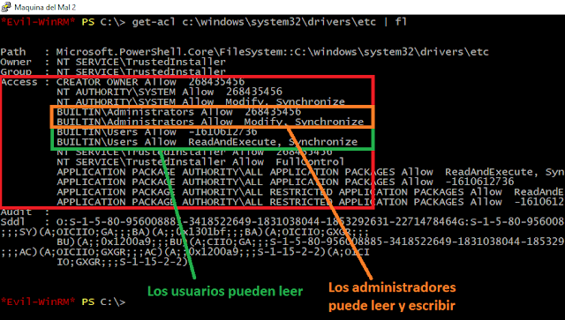
So if we try to create a file with our user hackplayers_backup, it should not allow us in that path. So we try to do an “echo hello > c:\windows\system32\drivers\etc
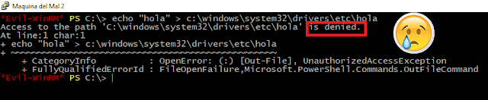
Indeed the system does not allow us. But what we can do is change the permissions of the path and become owners of said path. For this we will use a script that we uploaded a few months ago to the hackplayers github, Acl-FullControl . Which we will load into our Evil-WinRM session .
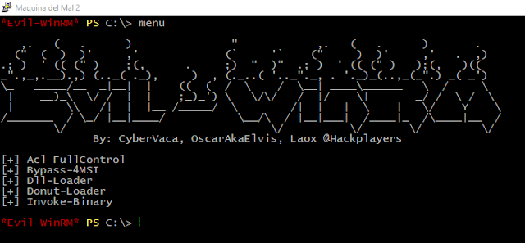
In case you are not using Evil-WinRM, it would be enough to use Import-module .\Acl-FullControl.ps1. However, since Evil-WinRM is a Hackplayers application, we use it. We execute Acl-FullControl to see what data is requested.
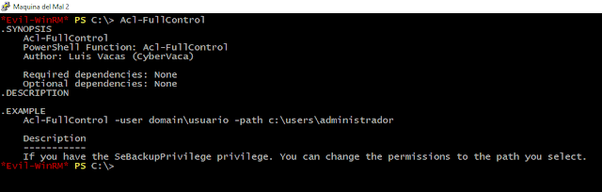
The script is very simple, it asks us to pass a domain + user ("if there is no domain, it is the hostname of the machine") and it also asks us for the path to which we want to change the permissions, simple, right? Let's see if works.
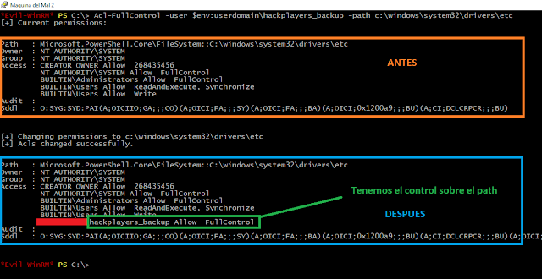
Great it seems that we have already taken control of the folder.
- With this we can write on the route?
- No cabesha, it is not possible yet, now we need to assign read and write permissions.
It would be enough to copy the ACLs from somewhere where we can write and assign it to this path. So we will get the ACLs of a writable path and set it to “c:\windows\system32\drivers\etc”, in our case we will choose a path where any user on the system can write (“c:\ programdata”).
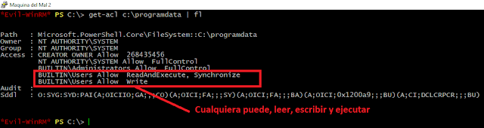
Well, it would be enough to set this acl to the target route. We will use the powershell cmdlets that are current in powershell since powershell version 3.0. To do this we will do a get-acl and send it to set-acl and the target path.
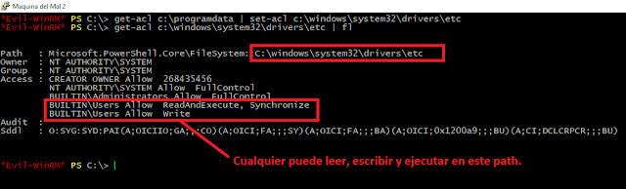
And indeed we can already write in this path in which we should not have permissions.
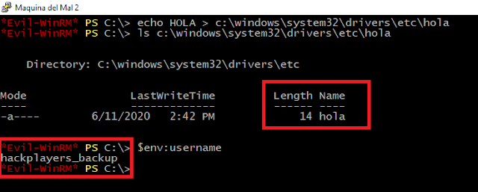
• Well, this looks cool. But… could we escalate privileges with this?
• Off course, my weapon. (Of course, my weapon)
We could write a binary somewhere that we know would be executed on a reboot. But we don't like to wait, so we'll tell you something. The Microsoft Windows VDS service.
VDS Service
➔ Virtual Disk Service is a Microsoft Windows service that performs query and configuration operations at the request of end users, scripts, and applications. The service extends the existing storage capabilities of Windows Server operating systems. And if we are inside the "backups operators" group, we can stop it and start it.
In such a way that we could use the technique that we have just seen, to get hold of the binary of the VDS service that is in “c:\windows\system32\vds.exe”.
• What is our plan?
1. Save a backup of the ACLs of c:\windows\system32
2. Take control of c:\windows\system32
3. Set a read and write ACL
4. Modify the vds service binary
5. Start the service vds with our malicious binary
6. Leave the system as it was before the attack.
But this is a pain to do it by hand, are we hacker or are we fucking loosers? So to carry out all this attack by concatenating Windows features we have created the “Backup-ToSystem” powershell script. The module is available here. (“ https://raw.githubusercontent.com/Hackplayers/PsCabesha-tools/master/Privesc/Backup-ToSystem.ps1 ”)
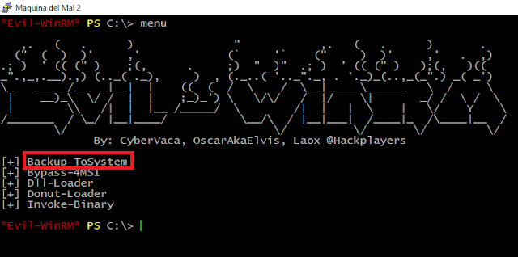
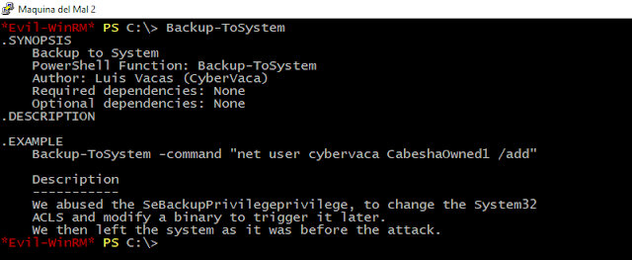
As you can see, the module only asks us to enter the command to execute.
We will run the module and try to create a user. But first we will verify that we do not have sufficient permissions to create users in the system.
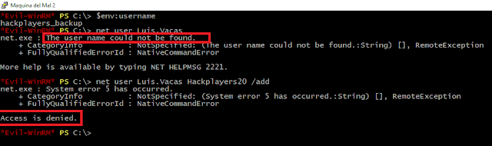
We execute the module by passing the command to create a user:
Backup-ToSystem -command "net user Luis.Vacas Hackplayers20 / add"
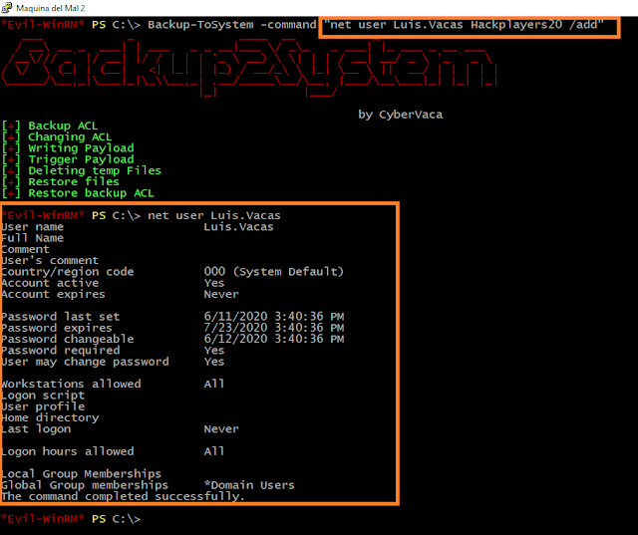
Effectively our module is running as system, so we could run whatever we wanted as authority system. To finish, what we will do is create a Shell with our Reverse Shell generation tool. What do you have in (“ https://github.com/Hackplayers/ReverseShell ”)
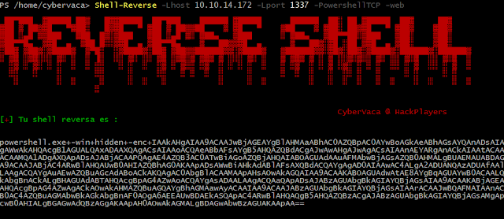
We copy all the base64 and pass it to Backup-ToSystem as an argument and in another shell we leave a netcat listening.
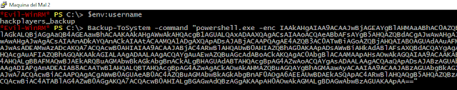
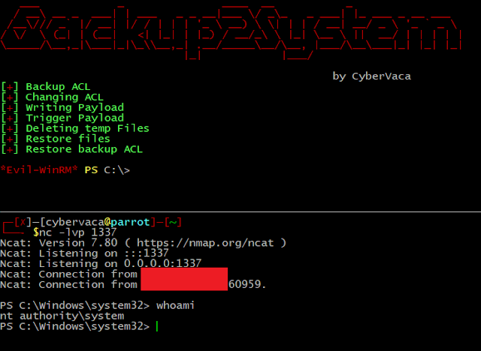
This way we would get our beloved Shell from “nt authority\system”. So now you know if you have Backup privileges, it's a full-fledged Game Over. I hope you liked it, at least it has entertained me to explain it to you. All the best.
tools powershell techniques

